Project 1 Report

Name: Xujia Qin

**Required image 1**

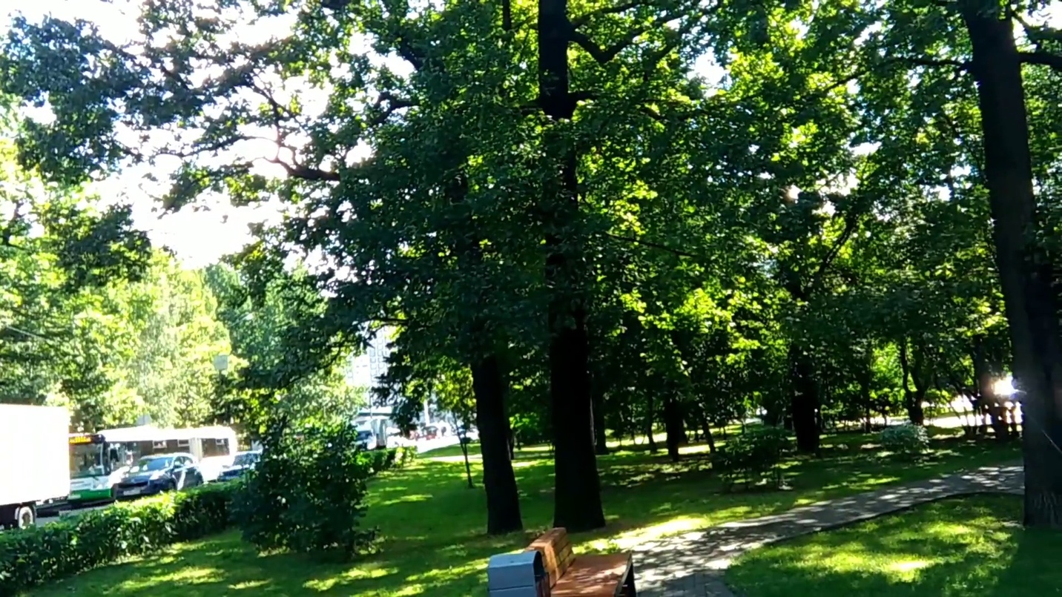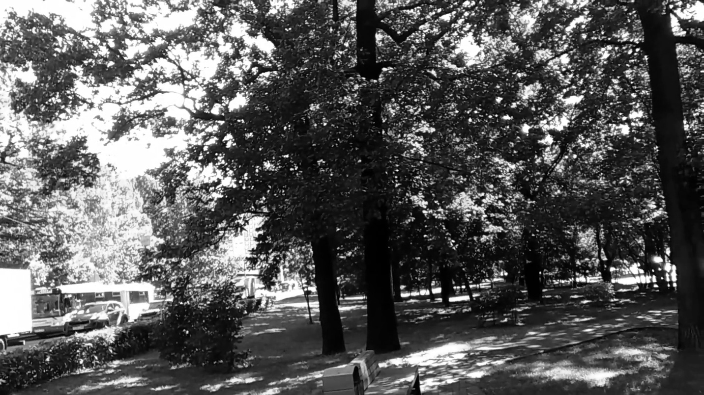

**Required image 2**

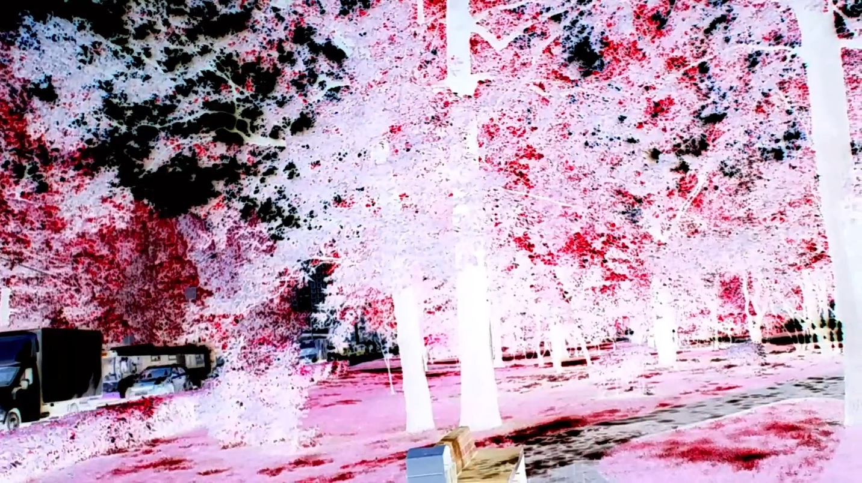

To generate the grayscale version, I used a color inversion method rather than the typical weighted average of the RGB channels.

For each pixel: Red, Green, and Blue channels are inverted: r = 255 - pixel[2], g = 255 - pixel[1], b = 255 - pixel[0].

Differences from Default Grayscale:

Brightness: The default grayscale preserves brightness, while the inverted method alters brightness, resulting in complementary color contrasts.

Color: Default grayscale converts to shades of gray, whereas the inverted method keeps the complementary colors (e.g., red becomes cyan).

**Required image 3**

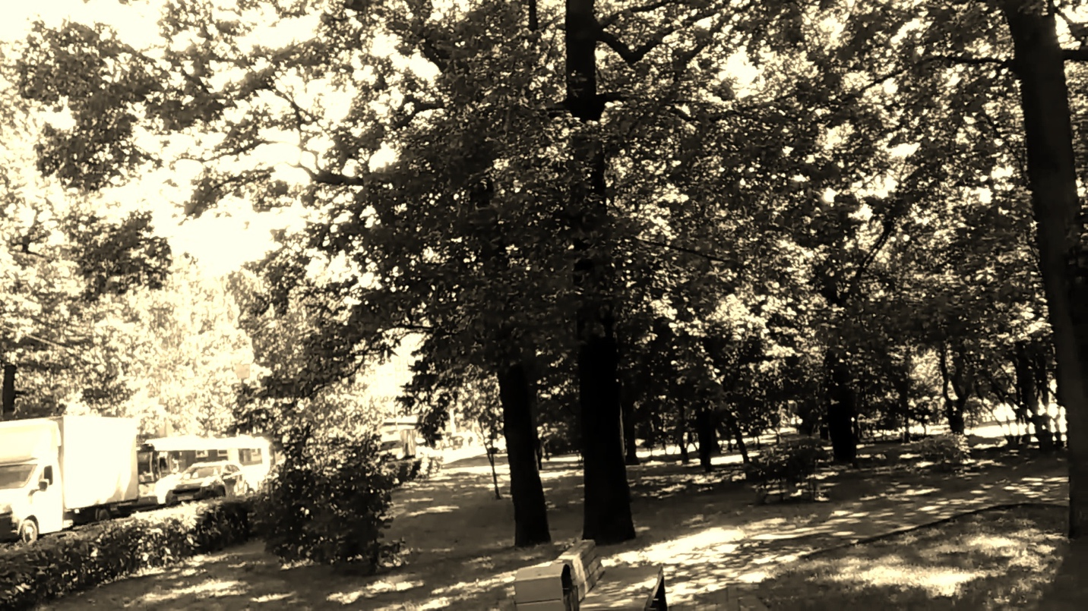

To ensure the computation uses the original RGB values, the code reads the source pixel values (B, G, R) before any computation, ensuring transformations are based on unmodified values. Each new channel value (newB, newG, newR) is computed independently without relying on intermediate results.

**Implement a 5x5 blur filter**

1. Time per image (1): 0.2296 seconds
2. Time per image (2): 0.1381 seconds

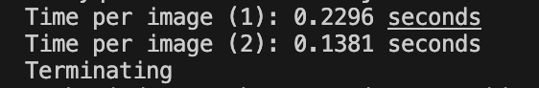

Why the 2nd method it’s faster:

I use separable filter 1*5 and 5*1 matrix to implement the blurring, so that it can reduce the operations compared with the 5 *5 Gaussian blurring.

From (25 + 24 + 1) = 50 ops per pixel reduce to (5 + 4 + 1) * 2 = 20 ops per pixel.

**Required Image 4:** the blurred image

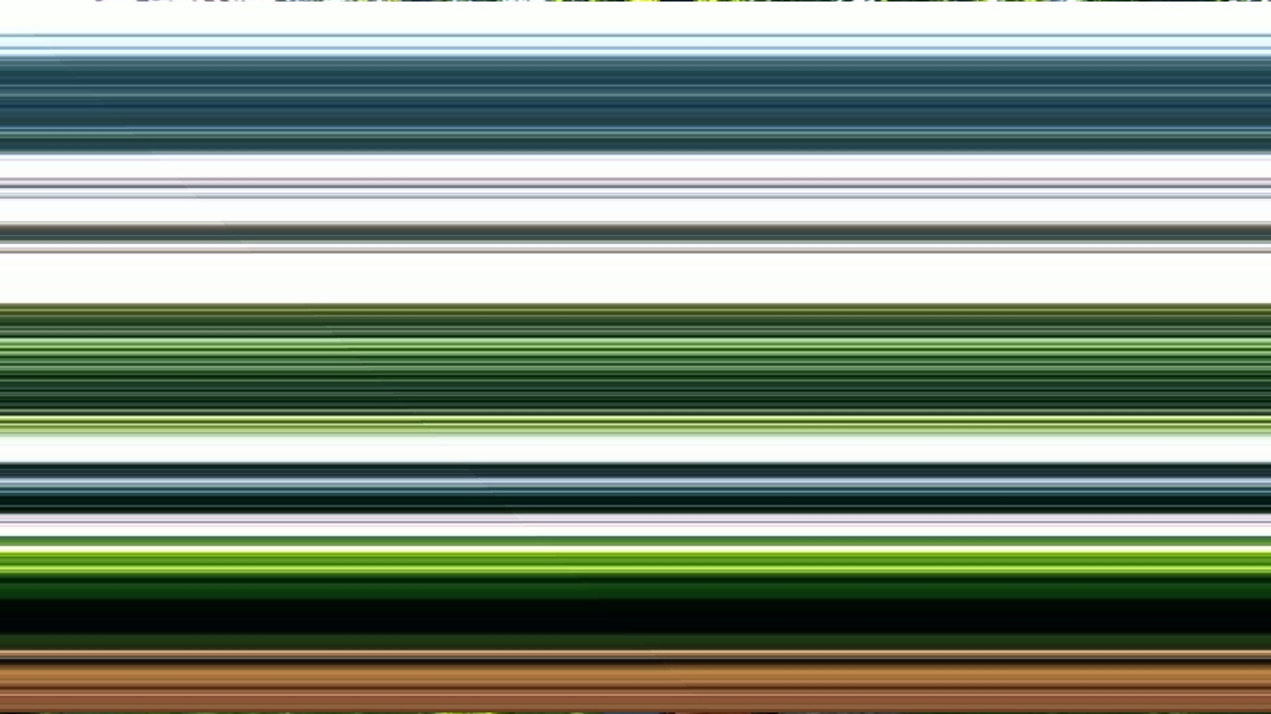

**Required Image 4:** gradient magnitude image from the X and Y Sobel images

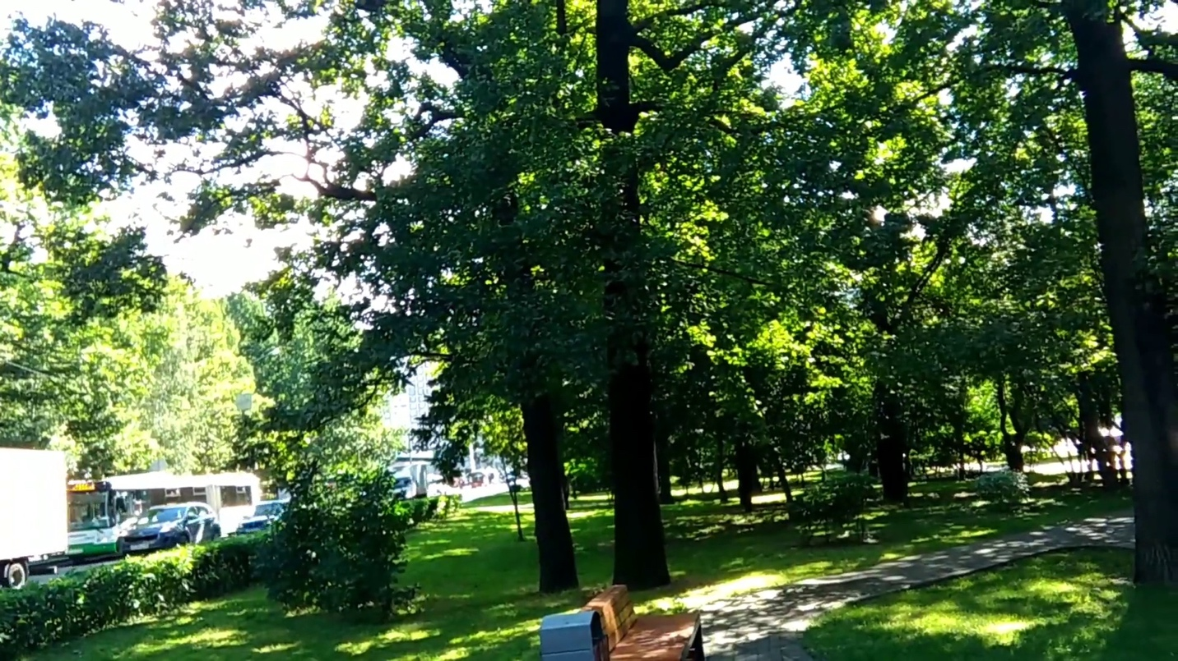

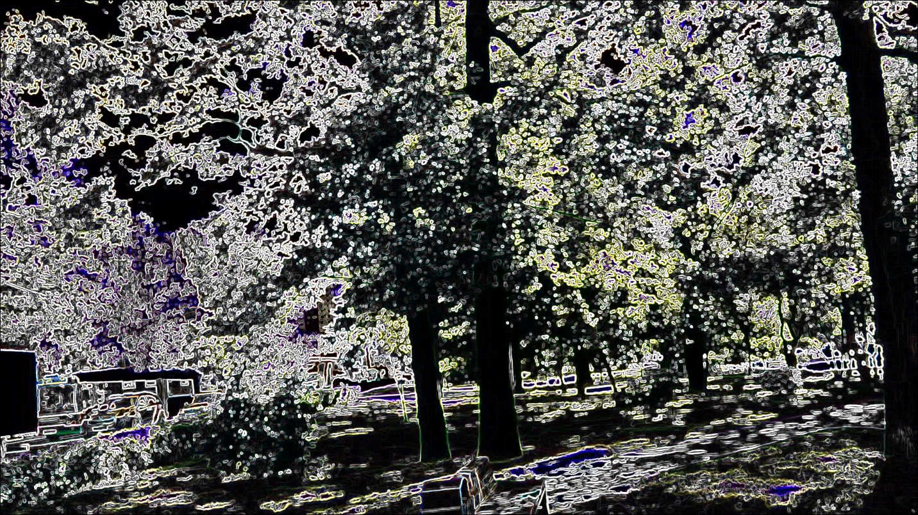

**Required Image 5: blurs and quantizes a color image**



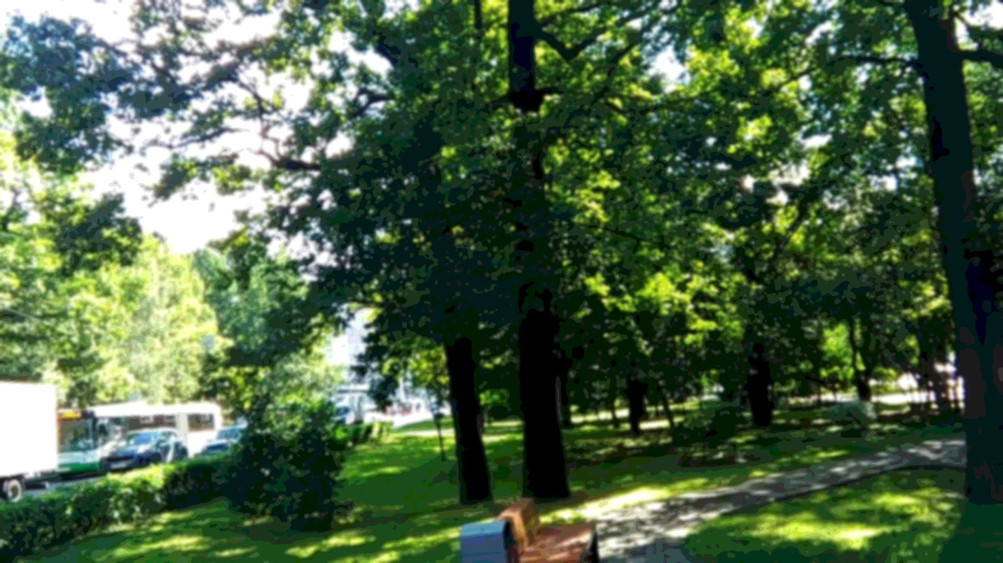

**Required Image 6: face detected**

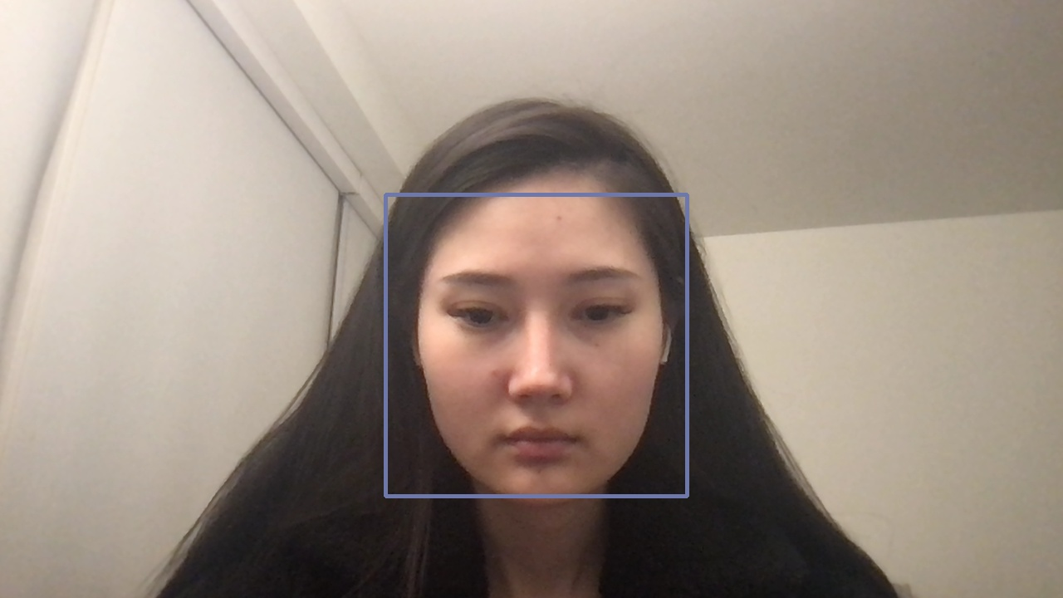

**Required Images 7: a depth image from my video stream**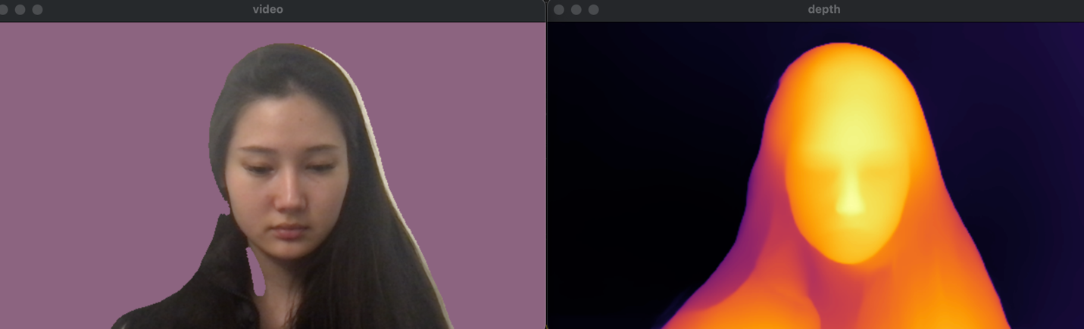

**Required Images 8: an image of sepia tone filter using depth values**

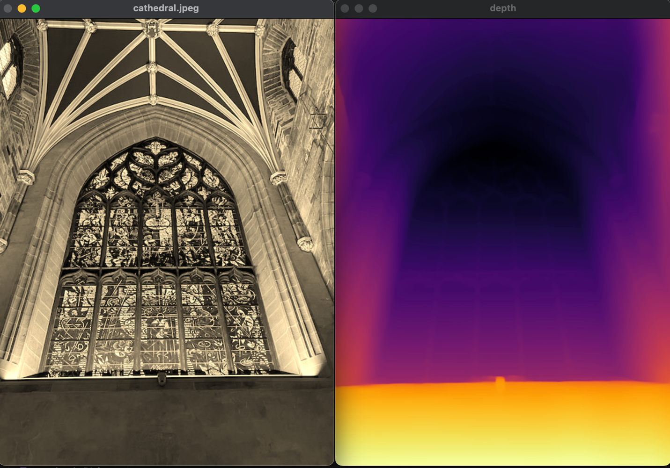

**scale depth values by 5**

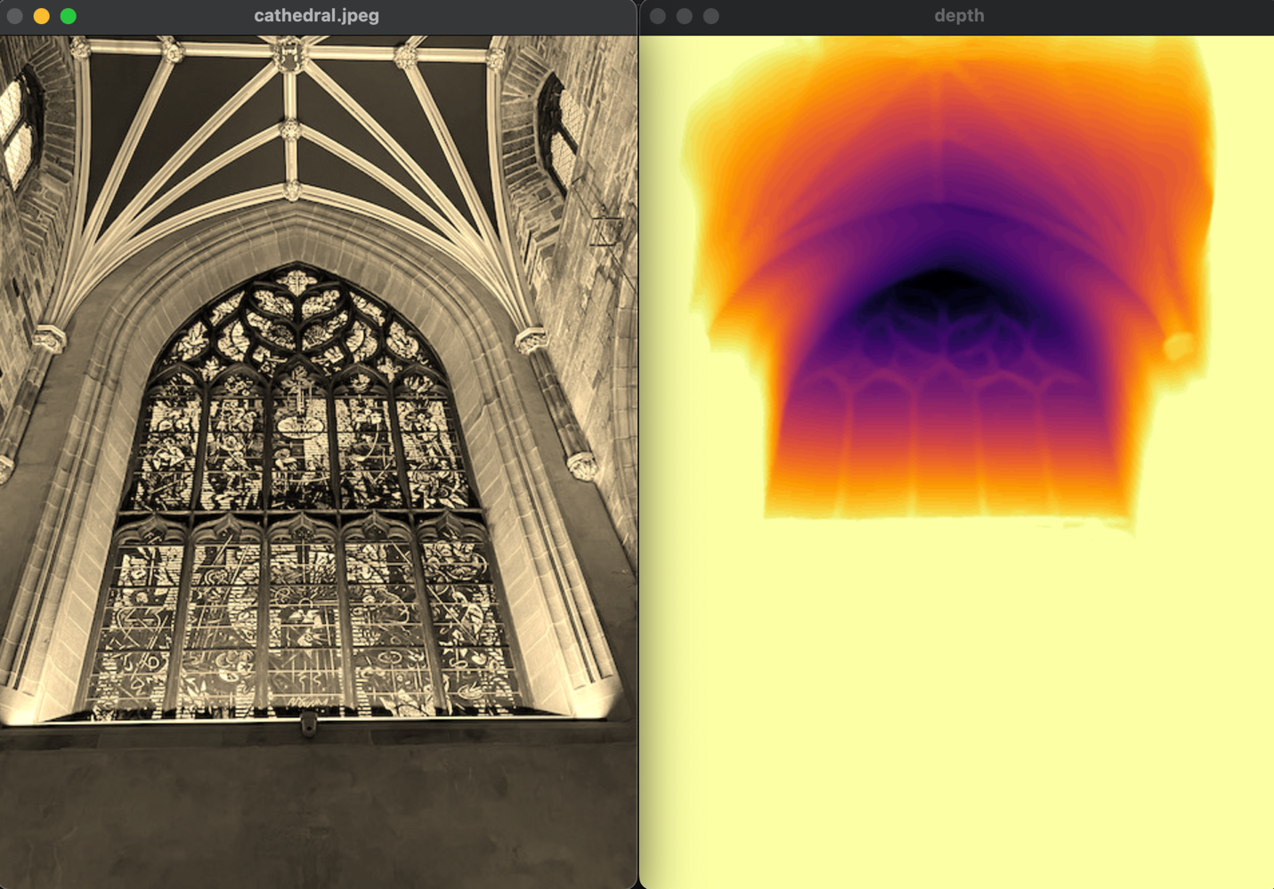

**Required Images 9-11:**

**Cartoon effect:**

The function first converts the image to grayscale and applies a median blur to reduce noise. It then detects edges, applies a bilateral filter to smooth colors while preserving edges, and combines the edges with the quantized colors for a cartoonish effect.

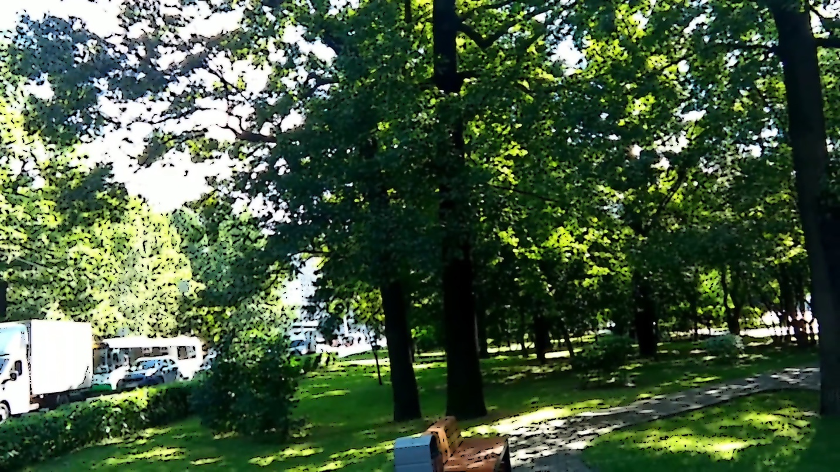

**Emboss effect:**

This effect computes Sobel gradients to detect edges in both X and Y directions, then applies a directional vector to create the embossing effect. The result is normalized to 8-bit values for display, enhancing the edge and depth perception.

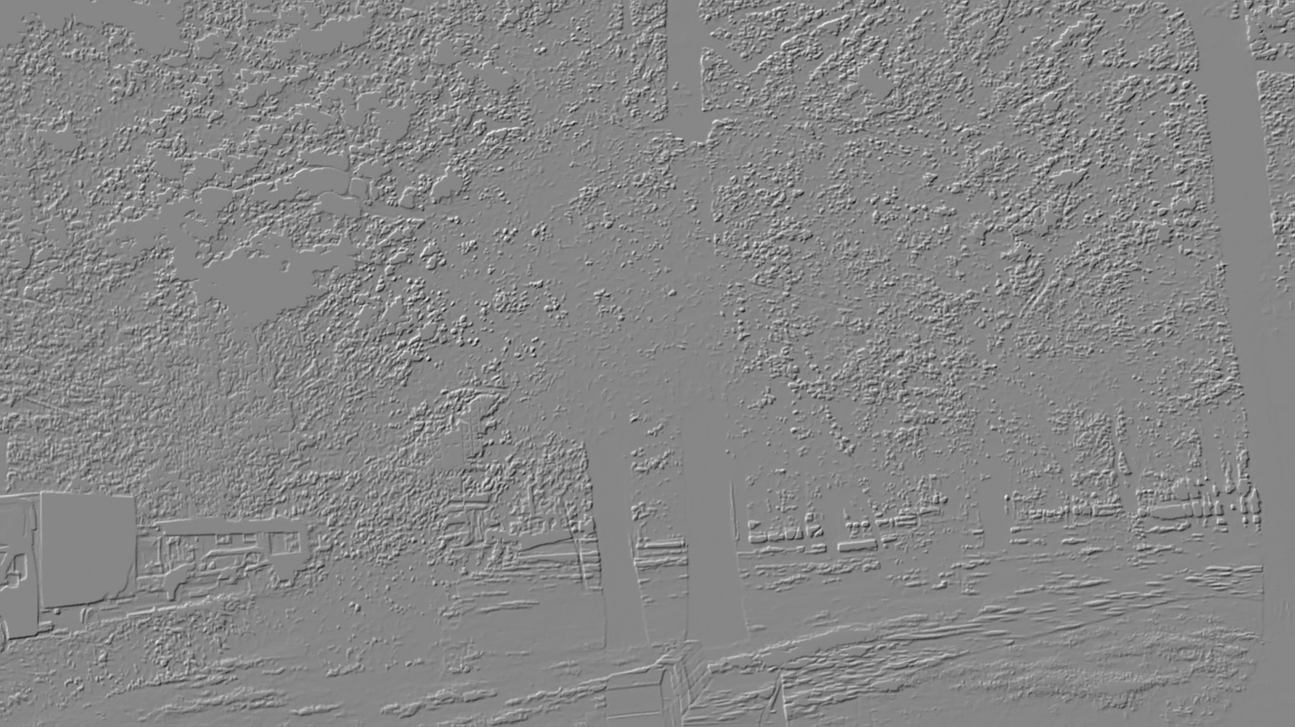

**Face blurred effect:**

The applyFaceBlur function loops through each detected face in the faces vector and extracts the region of interest (ROI) corresponding to the face. It then applies a Gaussian blur to the face ROI with a kernel size of 15x15, which can be adjusted to control the blur strength.

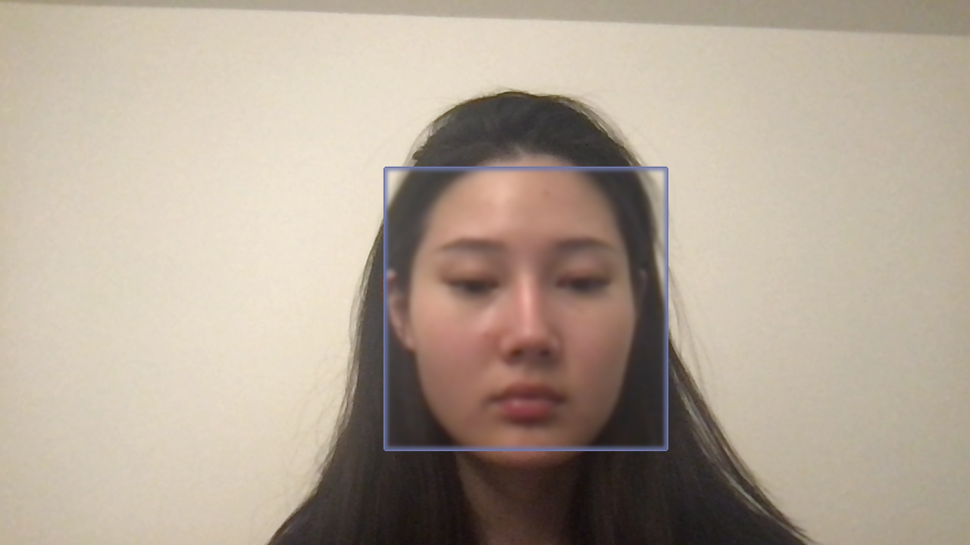

**Extensions:**

1. **Vignette filter:**

Based on the sepia filter, I’ve calculated the vignette factor (1.0 - (dist / maxDist)) for each pixel and then adjust the sepia-toned values based on the distance of the pixel from the image center.

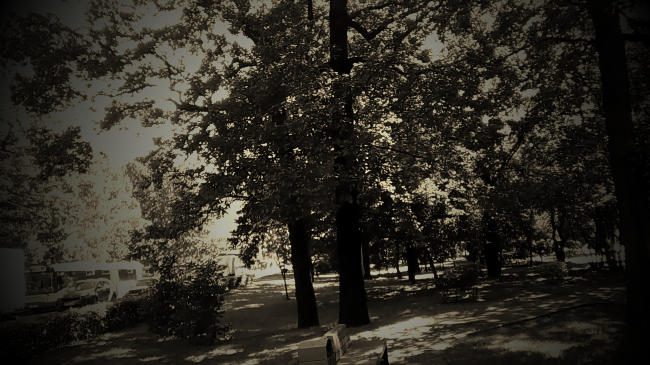

1. **Pencil sketch**

The pencilSketch function converts an input image to grayscale, inverts the grayscale image, and applies a Gaussian blur to the inverted image. It then creates a pencil sketch effect by dividing the grayscale image by the blurred inverted image.

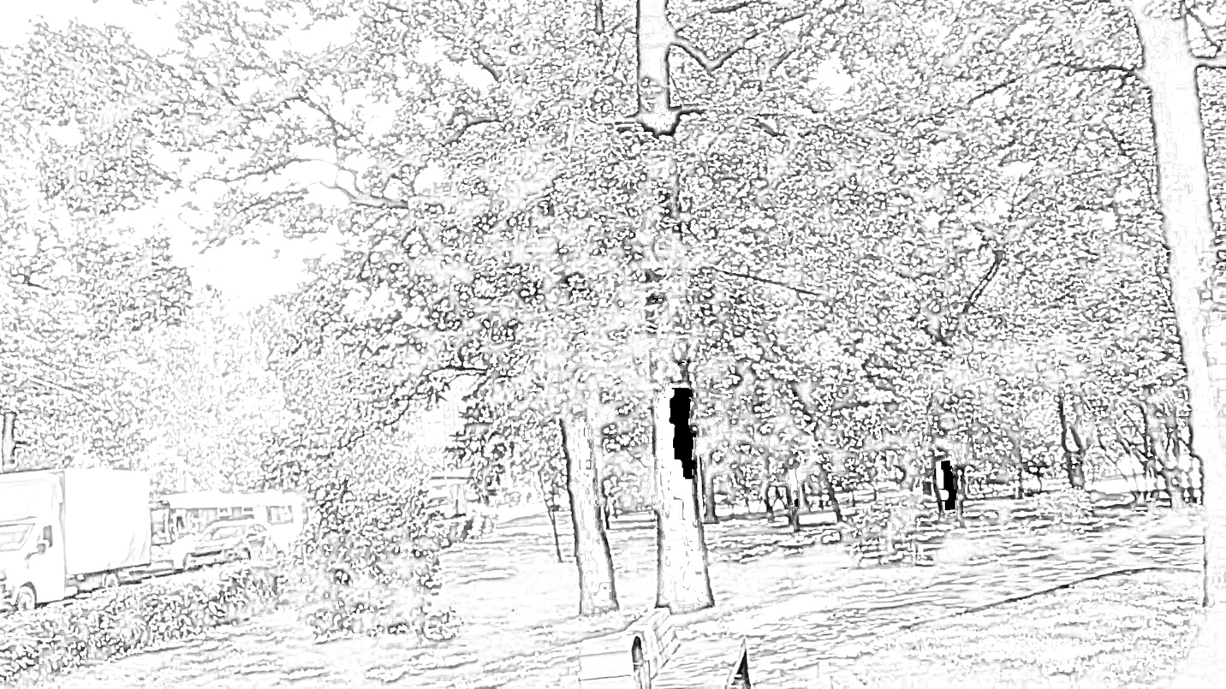

1. **Oil painting**

Use opencv xphoto library with oil painting intrinsic effect

The image is converted to the default color space, COLOR_BGR2GRAY. For each pixel, the program calculates a histogram of its neighbors (size 2*size+1) in the first color plane and assigns the most frequent value. This results in an oil painting-like effect. Parameter 4 of oilPainting method reduces the image's dynamic range, enhancing the effect.

